PANJAB UNIVERSITY, CHANDIGARH


Candidate’s Declaration

We hereby certify that the work presented in the Project entitled “Hand Gestured Controlled Metal Detector Robot” in the fulfilment of innovative summer project is an authentic record of our own work carried out under the supervision and guidance of Mrs. Garima Joshi (Professor) University Institute of Engineering and Technology, Panjab University, Chandigarh.

Date: 26th JULY 2017


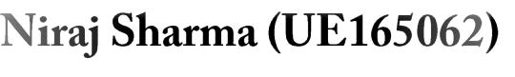


Certificate

This is to certify that the above statement made by the candidate is correct to the best of my knowledge and belief.

Place: Chandigarh

___________________________

Mrs. Garima Joshi

ECE Dept.

UIET, Panjab University
Contents

1. | Introduction
2. | Essential Components
3. | Electrical Components
4. | Steps of Construction
5. | Advantages
6. | Disadvantages
7. | Applications
8. | Conclusion

Acknowledgement

We have taken efforts in this project. However, it would not have been possible without the kind support and help of many individuals and organizations. We would like to extend my sincere thanks to all of them.

We are highly indebted to Mrs. Garima Joshi, ECE Dept. for their guidance and constant supervision as well as for providing necessary information regarding the project & also for their support in completing the project.

We would like to express my gratitude towards our parents & staff of UIET, Panjab University for their kind co-operation and encouragement which help me in completion of this project.

Our thanks and appreciations also go to my colleagues in developing the project and people who have willingly helped me out with their abilities.

JULY, 2017 | Manik Dalal (UE164029)
 | Sahil Jaglan (UE165095)
 | Niraj Sharma (UE165062)
 | Mayank Bhardwaj
 | (UE168066)

INTRODUCTION

Humans are anxiously working on finding new ways of interacting with machines. However, a major breakthrough was observed when gestures were used for this interaction. A gesture is a form of non-verbal communication in which visible bodily actions communicate particular messages. It comprises of sound, light variation or any type of body movement. Land rovers are the vital part of almost all the industries which performs various different tasks such as welding, trimming, picking and placing etc. Moreover the biggest advantage of these arms is that it can work in hazardous areas and also in the areas which cannot be accessed by human. The gesture based system (using Accelerometer) has been incorporated to control the land rover as well as its platform using one, small and low-cost, 3-axis accelerometers. The prime aim of the design is that the robot and platform starts the movement as soon as the operator makes a gesture or posture or any motion. The Land rover is synchronized with the gestures (hand postures) of the operator.

Gesture is a most natural, expressive was of communication between Human and Computer in real system. We naturally use various gestures to express our own intension in everyday life. We have proposed a method where the movements of robot are controlled by hand gestures. We formulated the relation between hand gestures and Accelerometer and designed a new way of communicating robot with hand gestures in different modes. Based on hand gestures the output is generated by the Arduino software. The corresponding outputs of Arduino are given as input to Motor driver (L293D). This runs DC Motor accordingly and robot moves. This robot can be moved forward and backward directions using DC Motors. Also takes sharp turnings towards left and right directions. This project is designed to develop robot that can sense metals ahead of it on its path even in dim or no light conditions. On detection the frequency of the buzzer changes which alerts the user to notify about it. Reduction of human activities in dangerous environment is the main objective of employing this robot.
Essential Components

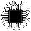 ARDUINO UNO

Arduino is an open source computer hardware and software company, project, and user community that designs and manufactures single-board microcontrollers and microcontroller kits for building digital devices and interactive objects that can sense and control objects in the physical world. The project's products are distributed as open-source hardware and software, which are licensed under the GNU Lesser General Public License (LGPL) or the GNU General Public License (GPL), permitting the manufacture of Arduino boards and software distribution by anyone. Arduino boards are available commercially in preassembled form, or as do-it-yourself kits.

Arduino board designs use a variety of microprocessors and controllers. The boards are equipped with sets of digital and analog input/output (I/O) pins that may be interfaced to various expansion boards (shields) and other circuits. The boards feature serial communications interfaces, including Universal Serial Bus (USB) on some models, which are also used for loading programs from personal computers. The microcontrollers are typically programmed using a dialect of features from the programming languages C and C++. In addition to using traditional compiler toolchains, the Arduino project provides an integrated development environment (IDE) based on the Processing language project.

The Arduino project started in 2003 as a program for students at the Interaction Design Institute Ivrea in Ivrea, Italy, aiming to provide a low-cost and easy way for novices and professionals to create devices that interact with their environment using sensors and actuators. Common examples of such devices intended for beginner hobbyists include simple robots, thermostats, and motion detectors.
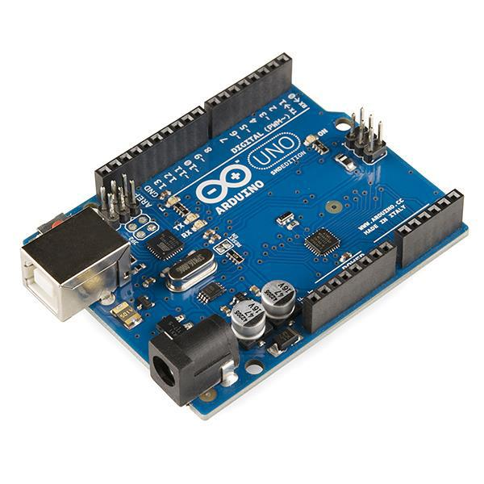

Fig 1. Arduino Uno R3
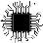 ADXL335 Accelerometer

The ADXL335 is a complete 3-axis acceleration measurement system. The ADXL335 has a measurement range of ±3g minimum. It contains a polysilicon surface-micro machined sensor and signal conditioning circuitry to implement an open-loop acceleration measurement architecture. The output signals are analog voltages that are proportional to acceleration. The accelerometer can measure the static acceleration of gravity in tilt-sensing applications as well as dynamic acceleration resulting from motion, shock, or vibration. The sensor is a polysilicon surface-micro machined structure built on top of a silicon wafer. Polysilicon springs suspend the structure over the surface of the wafer and provide a resistance against acceleration forces. Deflection of the structure is measured using a differential capacitor that consists of independent fixed plates and plates attached to the moving mass. The fixed plates are driven by 180° out-of-phase square waves. Acceleration deflects the moving mass and unbalances the differential capacitor resulting in a sensor output whose amplitude is proportional to acceleration. Phase-sensitive demodulation techniques are then used to determine the magnitude and direction of the acceleration. The demodulator output is amplified and brought off-chip through a 32 kΩ resistor. The user then sets the signal bandwidth of the device by adding a capacitor. This filtering improves measurement resolution and helps prevent aliasing.
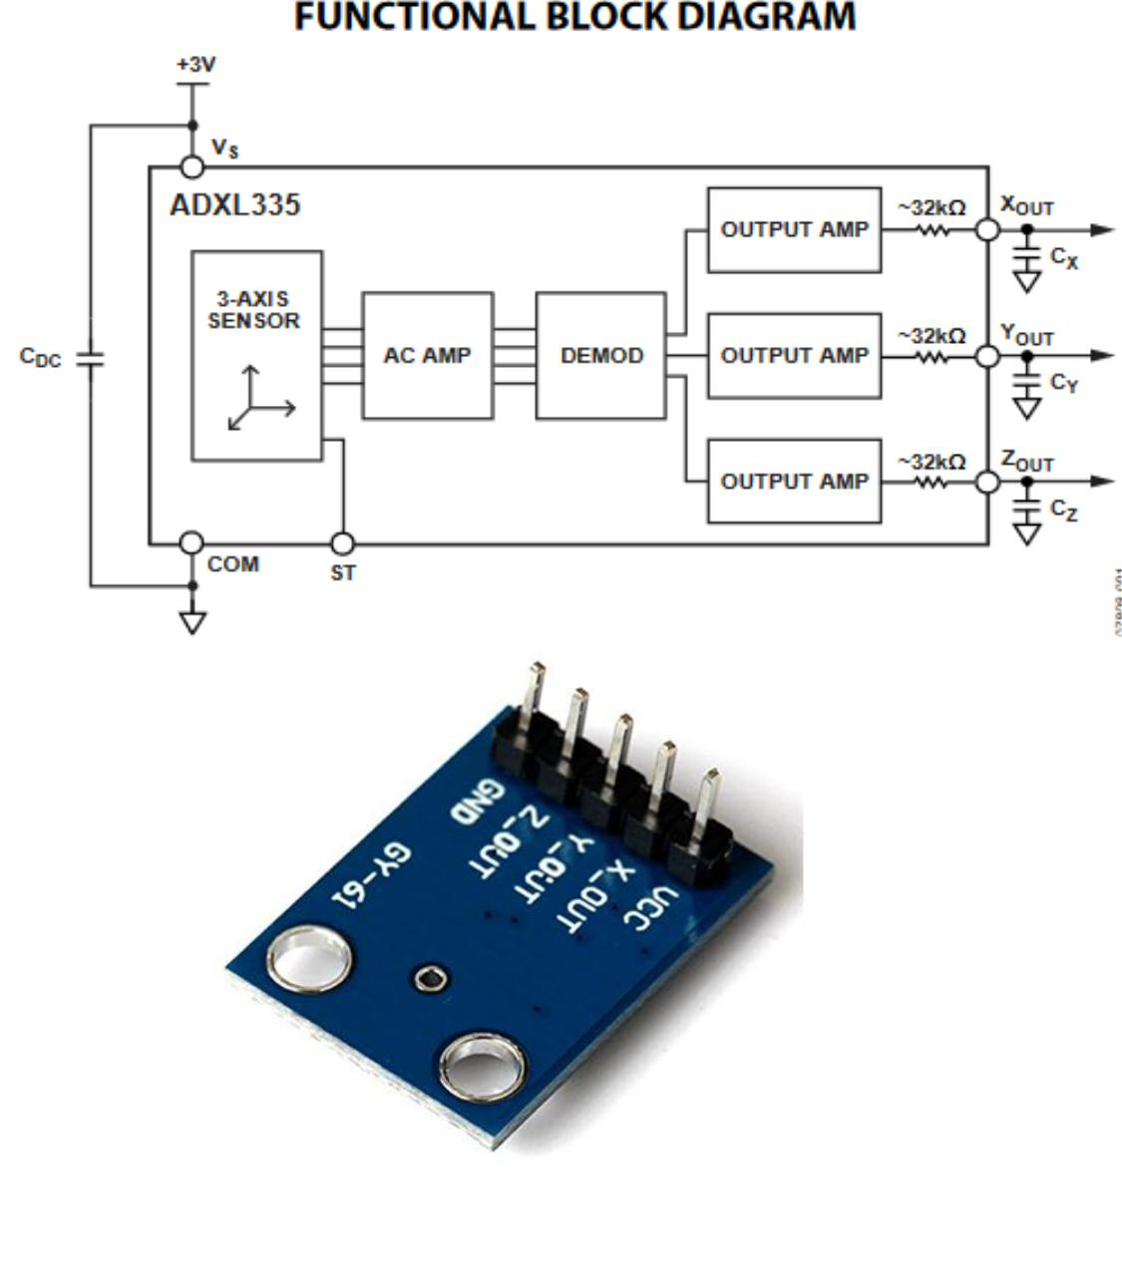

Fig 2. ADXL335 Accelerometer

L293D MOTOR DRIVER IC

L293D is a dual H-bridge motor driver integrated circuit (IC). Motor drivers act as current amplifiers since they take a low-current control signal and provide a higher-current signal. This higher current signal is used to drive the motors.L293D contains two inbuilt H-bridge driver circuits. In its common mode of operation, two DC motors can be driven simultaneously, both in forward and reverse direction. The motor operations of two motors can be controlled by input logic at pins 2 & 7 and 10 & 15. Input logic 00 or 11 will stop the corresponding motor. Logic 01 and 10 will rotate it in clockwise and anticlockwise directions, respectively. Enable pins 1 and 9 (corresponding to the two motors) must be high for motors to start operating. When an enable input is high, the associated driver gets enabled. As a result, the outputs become active and work in phase with their inputs. Similarly, when the enable input is low, that driver is disabled, and their outputs are off and in the high-impedance state.
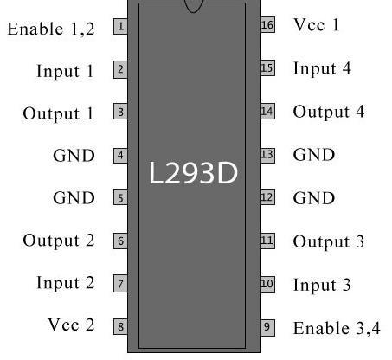

Fig 3. PIN DIAGRAM OF L293D IC

555 TIMER IC

The 555 timer IC is an integrated circuit (chip) used in a variety of timer, pulse generation, and oscillator applications. The 555 can be used to provide time delays, as an oscillator, and as a flip-flop element. Derivatives provide two

- or four (558) timing circuits in one package. Introduced in 1972 by Signetics, the 555 is still in widespread use due to its low price, ease of use, and stability. It is now made by many companies in the original bipolar and in low-power CMOS. As of 2003, it was estimated that 1 billion units were manufactured every year. The 555 is the most popular integrated circuit ever manufactured.
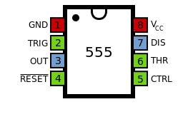

Fig 3. PIN DIAGRAM OF 555 IC

PHOTORESISTOR

A photo resistor (or light-dependent resistor, LDR, or photoconductive cell) is a light-controlled variable resistor. The resistance of a photo resistor decreases with increasing incident light intensity; in other words, it exhibits photoconductivity. A photo resistor can be applied in light-sensitive detector circuits, and light- and dark-activated switching circuits. A photo resistor is made of a high resistance semiconductor. In the dark, a photo resistor can have a resistance as high as several megohms (MΩ), while in the light, a photo resistor can have a resistance as low as a few hundred ohms. If incident light on a photo resistor exceeds a certain frequency, photons absorbed by the semiconductor give bound electrons enough energy to jump into the conduction band. The resulting free electrons (and their hole partners) conduct electricity, thereby lowering resistance. The resistance range and sensitivity of a photo resistor can substantially differ among dissimilar devices. Moreover, unique photo resistors may react substantially differently to photons within certain wavelength bands. A photoelectric device can be either intrinsic or extrinsic. An intrinsic semiconductor has its own charge carriers and is not an efficient semiconductor, for example, silicon. In intrinsic devices the only available electrons are in the valence band, and hence the photon must have enough energy to excite the electron across the entire bandgap. Extrinsic devices have impurities, also called dopants, added whose ground state energy is closer to the conduction band; since the electrons do not have as far to jump, lower energy photons (that is, longer wavelengths and lower frequencies) are sufficient to trigger the device. If a sample of silicon has some of its atoms replaced by phosphorus atoms (impurities), there will be extra electrons available for conduction. This is an example of an extrinsic semiconductor.
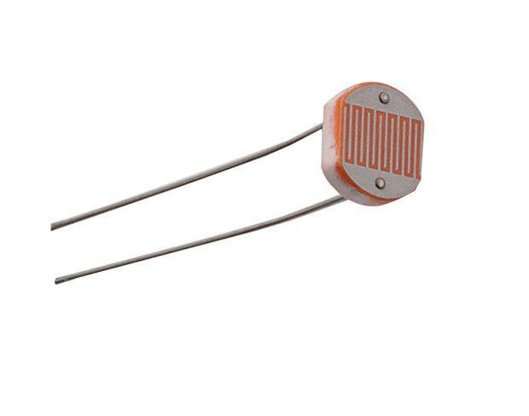

Fig 4. PHOTORESISTOR
Electrical Components

Breadboard

DC Motors

Jumper Wires

47 kΩ Resistor

2.2µF Capacitor

Buzzer

Copper Wire

240 ohm Resistors

LED

BATTERY 9V

L298 Voltage Regulator

Wires

Steps of Construction

STEP-1 CHASSIS

Fix the wheels on the chassis. Mount the DC motors on the back wheels and use dummy wheels for the front. Mount the L293D IC on the breadboard and place it on the chassis. Make the connections of L293D as follows:
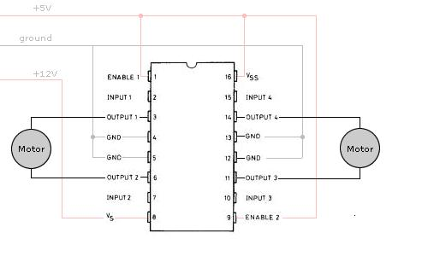

-4, 5, 12, 13 to GND

-1, 9, 16 to VCC (5V)

-3, 6 to left motor (output)

-11, 14 to right motor (output)

-2, 7, 10, 15 to pins 8, 9,10,7 of Arduino (inputs)

-8 to 9V battery

STEP-2 LDR CIRCUIT

You connect the components as shown in the diagram below. Connect the LEDs to pin 3 of the Arduino. The two 470 ohm resistors are current limiting resistors. One lead of the photo resistor is connected to 5V, the other to one lead of the 1 k ohm resistor. The other lead of the 10 k ohm resistor is connected to ground. This forms a voltage divider, whose output is connected to pin A1 of the Arduino. As the light impinging on the photo resistor gets stronger, the resistance decreases, and the voltage output of the divider increase. The reverse happens, when the impinging light gets weaker
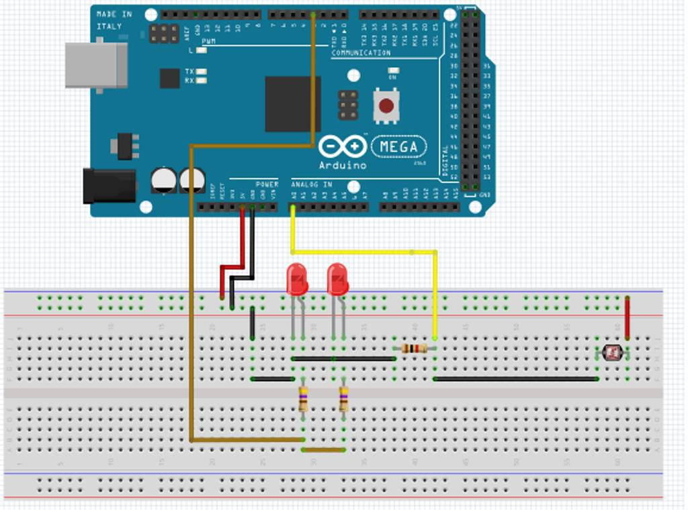

const int led=3;
void setup()

{
pinMode(led, OUTPUT);
}

void loop()

{
int sensor_value = analogRead(A0);
if (sensor_value < 150)
{
digitalWrite(led, HIGH);

}
else
{
digitalWrite(led,LOW);
}

}

STEP-3 METAL DETECTOR CIRCUIT

The figure shows the circuit diagram of metal detector. The 555 IC timer here acts as a square wave generator and it generate pulses with frequencies audible to human. The capacitor between pin2 and pin1 should not be changed as it is need to generate audible frequencies. In the circuit there is an RLC circuit formed by 47K resistor, 2.2µF capacitor, and 150turn inductor. This RLC circuit is the metal detection part. Now as mentioned earlier in previous section, a metal core inductor has a high inductance value over an air cored one. Remember the coil wound here is an air cored one, so when a metal piece is brought near the coil, the metal piece acts as a core for the air cored inductor. By this metal acting as a core, the inductance of the coil changes or increases considerably. With this sudden increase in inductance of coil the overall reactance or impedance of the RLC circuit changes by a considerable amount when compared without the metal piece.

At first when there is no metal piece the signal fed to speaker causes some audible sound. Now with the reactance change around the RLC circuit the signal sent to speaker will no longer be the same as before, because of this the sound produced by the speaker will be of different to the first one. So whenever a metal is brought near the coil, the impedance of RLC changes making the signal to change resulting in variation to sound generated in speaker.
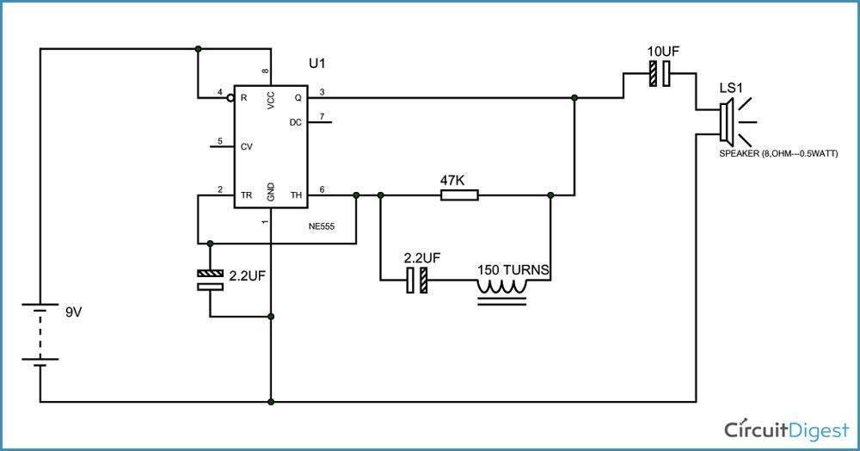
STEP-4 ACCELEROMETER CIRCUIT

Mount the Accelerometer on the breadboard and mount the breadboard on a glove for perfect detection of movement. Make the connections of Accelerometer as follows:

- GND to GND

-VCC to VCC (5V)

-2, 4 of Arduino to left motor (output)

-7, 8 of Arduino to right motor (output)

-X, Y, Z pins to pins A1, A2, and A3 of Arduino (inputs)

-Provide Power supply to the Arduino

Now upload the code to the Arduino and open serial monitor in the Arduino software. CHECK the values of the accelerometer on different gestures and accordingly calibrate the accelerometer by making changes in the source code. HENCE, the robot is ready to be tested.
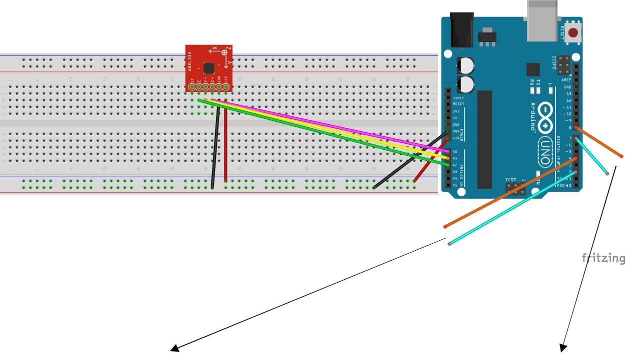

To Left Motor To Right Motor

Fig. Circuit Diagram of the Accelerometer

STEP-5 SOURCE CODE

void setup()

{

Serial.begin(9600);

pinMode(A0,INPUT);

pinMode(A1,INPUT);

pinMode(A2,INPUT);

pinMode(2,OUTPUT);

pinMode(4,OUTPUT);

pinMode(7,OUTPUT);

pinMode(8,OUTPUT);

}

void loop()

{

int xvalue=analogRead(0);

int yvalue=analogRead(1);

int zvalue=analogRead(2);

Serial.print("x: ");

Serial.print(xvalue);

Serial.print(" :: y: ");

Serial.print(yvalue);

Serial.print(" :: z: ");

Serial.print(zvalue);

Serial.print("\n");

if(xvalue>350 && xvalue<380)

{

if(yvalue>395)

{

digitalWrite(2,LOW);

digitalWrite(4,LOW);

digitalWrite(7,HIGH);

digitalWrite(8,HIGH);

Serial.print("Forward");
}

else if(yvalue<320)

{

digitalWrite(2,HIGH);

digitalWrite(4,HIGH);

digitalWrite(7,LOW);

digitalWrite(8,LOW);

Serial.print("Backward");

}

else

{

digitalWrite(2,LOW);

digitalWrite(4,LOW);

digitalWrite(7,LOW);

digitalWrite(8,LOW);

Serial.print("Stay");

}

delay(10);

}

else

{

if(xvalue<340)

{

digitalWrite(2,HIGH);

digitalWrite(4,LOW);

digitalWrite(7,LOW);

digitalWrite(8,LOW);

Serial.print("Left");

}

else if(xvalue>390)

{

digitalWrite(2,LOW);

digitalWrite(4,HIGH);

digitalWrite(7,LOW);

digitalWrite(8,LOW);

Serial.print("Right");
}

else

{

digitalWrite(2,LOW);

digitalWrite(4,LOW);

digitalWrite(7,LOW);

digitalWrite(8,LOW);

Serial.print("Stay");

}

}

}
ADVANTAGES

- It runs on electrical energy which makes it clean and efficient taking environment in aspect.

- Due to its small size it can traverse even in small and cramped locations.

- It will increase the efficiency of work and will reduce man hours from it.

- It will increase the safety of the operator.

- Could even work in dim or no light which is a plus point for the operator.

- It is much easier to control than the conventional metal detectors.

- Cost of operation and maintenance is less and easy.

- It is easy to modify the bot according to needs by simply removing that circuit from the bot.

- It is useful platform for other utilities as well.
DISADVANTAGES

- Hours of operation are limited by the capacity of the battery.

- Cost of manufacturing is high than the conventional metal detector.

- Electromagnetic Field could hinder the functioning of the electronic devices of the robot therefore isolation of electronic components is required.

- Electromagnetic rays are also harmful for people having pacemakers and they also infringe privacy concerns.

- The user needs to get training of the machine before using it.
APPLICATIONS

- Defence: Detecting land mines.

- Mining: Detecting minerals present in ground.

- Security: Detecting bombs.

- Civil Engineering: In construction industry for locating steel bars present in concrete.

- Homeland: In airports and building security to detect weapons.

- Archaeology: It can be used in archaeological sites for research work.

- Interchangeable Platform: It can used to modify the platform and change it according to our needs.

Conclusion

We formulated the design of metal detection using hand gestures and accelerometer. A 3-axis accelerometer and hand gesture is selected to be the input devices of this system. At receiver the land rover consists of metal detector is used. This approach using accelerometers is more intuitive and easy to work, besides offering the possibility to control a rover by wireless means. Using this system, a non-expert robot programmer can control a rover quickly and in a natural way even in dim or no light conditions.

